+
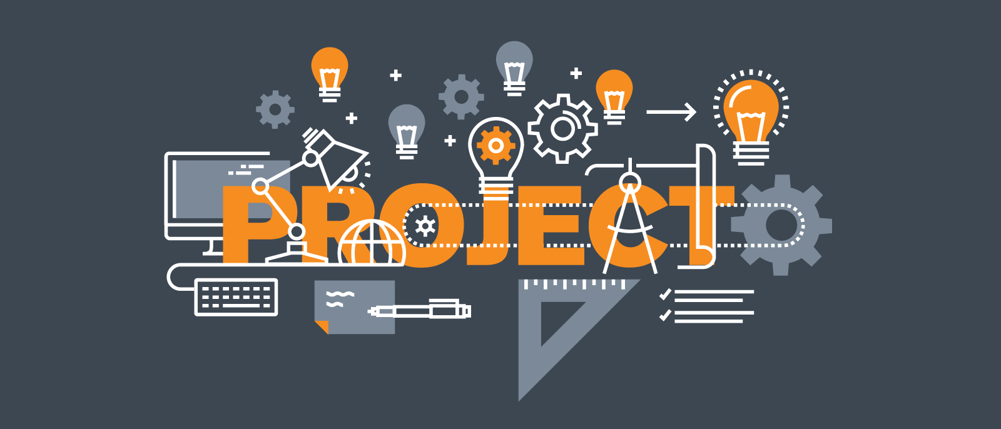  project 3: MEDI-STATION APP  TERM 4: INDIVIDUAL ASSIGNMENT | Name: Thabiso  Surname: Matsaba  Student Number: 220296006  Lecturer: Mrs  Karin Swart  Due: 24 October 2022  Project 3 GROUP 10

TABLE OF CONTENTS
Page

TABLE OF CONTENTS……............................................................................ ii
SECTION 1
Introduction....................................................................................................... 1
Kotlin belonging programming paradigms......................................................... 1
SECTION 2
Kotlin comparison on advantages, strengths, pitfalls with other programming languages in similar programming paradigms..................................................... 2
SECTION 3
How instructions written in Kotlin is executed by the computer.……………........................................................................................... 3
SECTION 4
The best use case(s) Kotlin.................................................................................. 4
SECTION 5
Bibliography……………………………………………………………………………. 5

Table of Contents
Project 3 Group 10 2
Medi-Station Application 2
What have you learnt? 4
Responsibilities 4
Recommendations for Improvement 5

- Project 3 Group 10
Medi-Station App
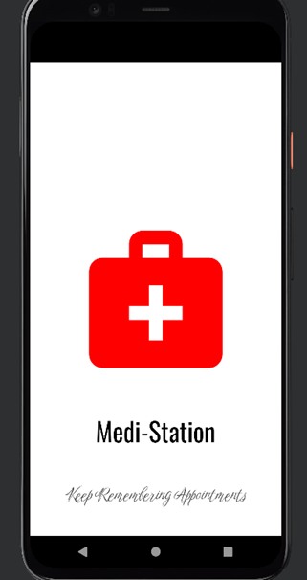

- Throughout the year, my group members and I are developed a private doctor application for android devices. The app keeps track of patient appointment history and/or upcoming appointments, so they'll never forget. Doctors are also able to see what sickness the patient has beforehand so they can be more prepared, and more patients can be seen per day. Since more people have smartphones and have access to the internet. It is a suitable application to use for the present time. Thus, more people will get familiar with it and upgrades can be made from the feedback.
- What have you learnt?
Skills acquired:
- I used a lot of relevant and useful technologies while programming my part of the application. I was not familiar with the Android Studio Integrated Development Environment (IDE), I therefore watched a lot of YouTube tutorials to teach myself how to use it. I also learnt a lot about User Experience (UX) best practices and how to code using business logic and rules. I also learnt a lot from LinkedIn Learning videos and tutorials on how to design, build, test and deploy Android applications using the Java programming language.
- The database I used for storing my data was Google’s Firebase Database a free cloud-based database for everyone looking to run small-scale to largescale applications anywhere in the whole world. Firebase handles all the complexity of deploying, managing, and handling your deployments on the cloud service provider of your choice Amazon Web Services (AWS), Microsoft Azure, and Google Cloud Platform (GCP).
- Android Development is not only an easy skill to learn, but also highly in demand. Despite Java being the official programming language for Android, not all applications are written in it. Most developers also use BASIC and Kotlin. In some rare cases, C++ can also be used.
Lessons learned:
- Most importantly, I have learned how to function more efficiently within a team. This is a very broad thing to say, because you do not simply learn this, but rather you learn multiple other aspects which contribute towards being able to work in a team. In my instance for example, I have learned patience, understanding and delegation.
- I needed to have patience because not all group members will be on the same page when it comes to opinions, meeting times, and ability. If I can complete something within 3 days that another member takes 6 days to do then that is not necessarily a bad thing, members can personally struggle more with that specific task, have other work arrangements in that time and many other reasons. The same goes the other way where I could take two times longer to complete another task when it is more aligned with another member’s skills and schedule, in which case I would want the same understanding from them.
- My learning of understanding closely follows that of patience. I learnt to understand that other group members have different skills and schedules, just as much I needed to be patient with it. It is one thing to be patient while awaiting feedback from group members, but it is another to have the understanding, so you do not place any blame or hold any undeserved grudges against fellow members.

- Responsibilities
- In our application, I have been tasked to code the Payment Gateway Interface. When the user is done booking an appointment, the user will be redirected to the payment interface to pay for the appointment. The user will have a payment number, receipt number, payment amount, payment type (card, cash or zapper) and the payment date.
- I was also responsible for testing, database design and packaging of the application.
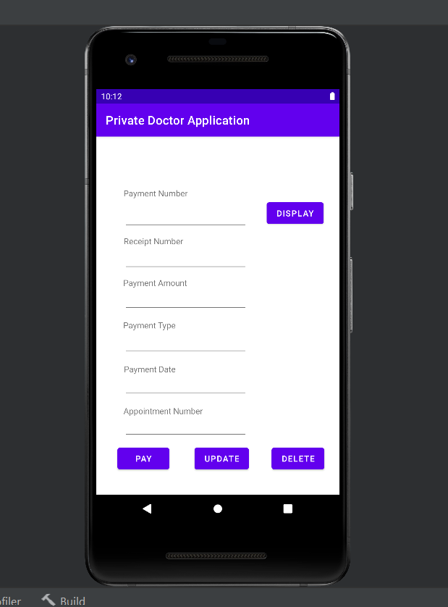
Figure1: Payment Gateway Interface

- Recommendations for Improvement
- Some of the functionalities to improve include:
- Automatically generating the Payment Number, Receipt Number and Appointment Number that points to the Doctor ID.
- The payment functionality must be handled by the application and not the user.
- The application must have an easy flow for the user to navigate.
- Perform file and network operations off the UI thread. They take time, and if done on the UI thread can make the app unresponsive, which can lead to “App Not Responding” error. They should always be performed on a worker thread, typically by using an AsyncTask/Loader.

